Skill Week 11
Aim
To create multiple C modules, connect them using a header file, compile and link the modules, validate the interface, and test the complete program execution.
Program:
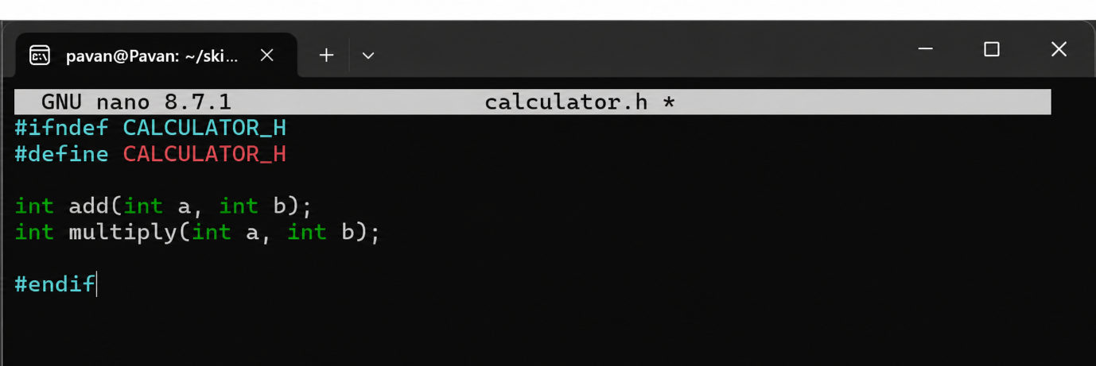
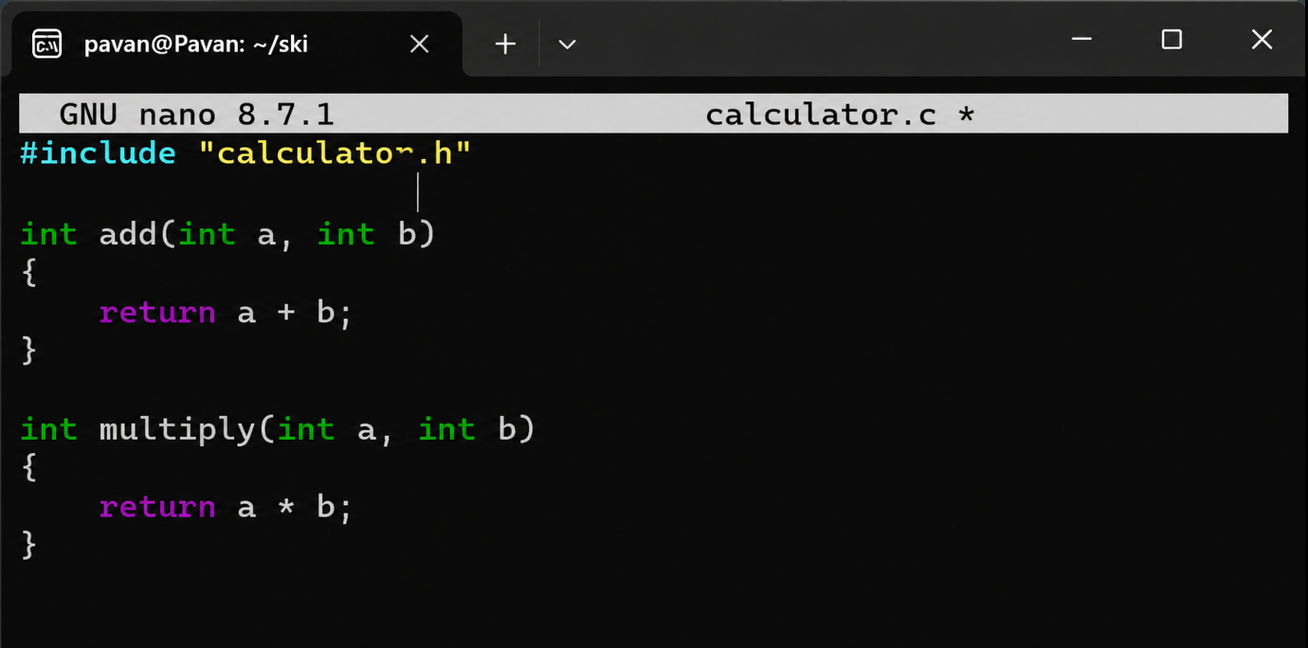

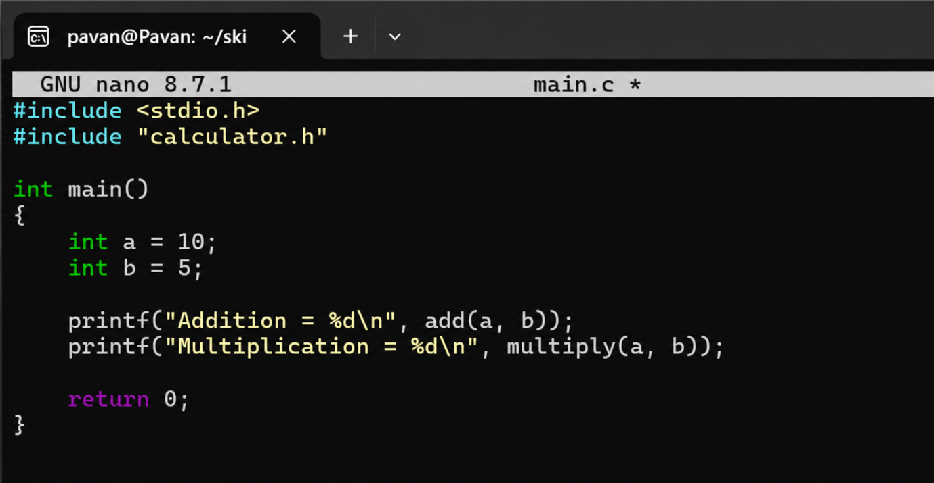

output
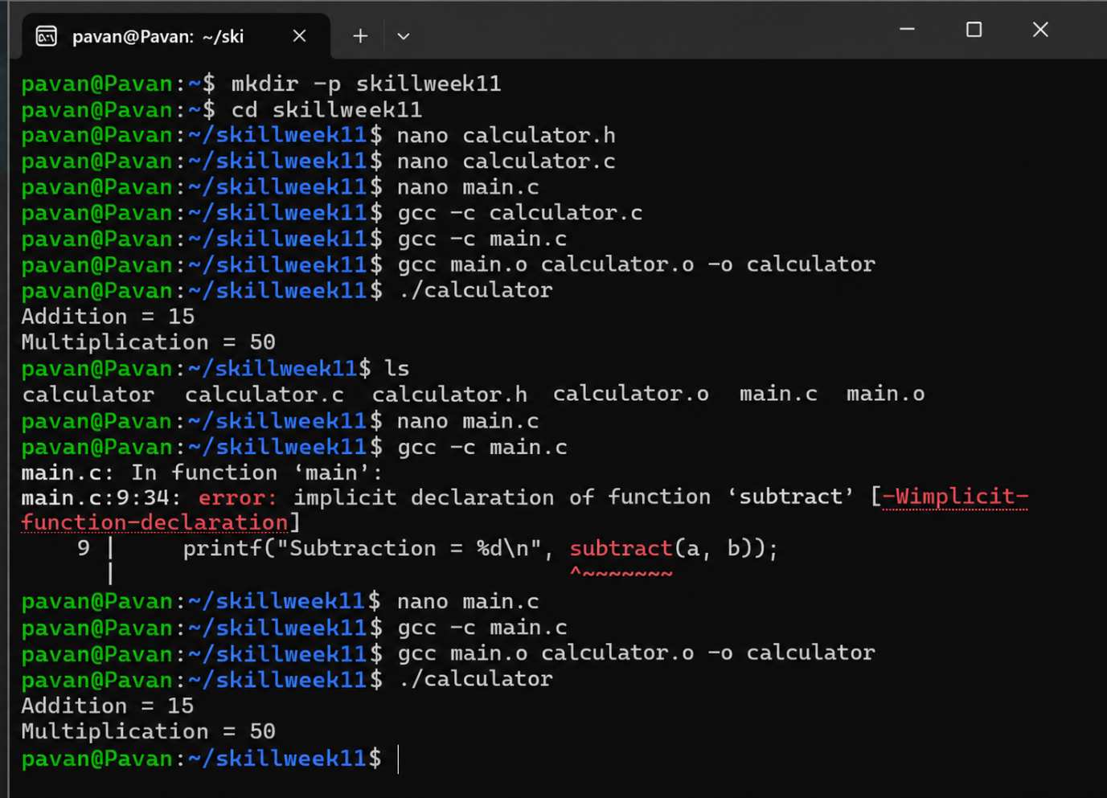

Observation
The header file provided the interface between main.c and calculator.c. Both modules were compiled separately and then linked together to produce one executable program. An invalid function interface generated a compilation warning/error.
Result
Multiple C modules were successfully connected, compiled, linked, tested, and validated for correct interface usage.

Aim
To create a C program that detects common runtime errors, displays meaningful error messages, logs failures into a file, and handles invalid input safely.
Program:
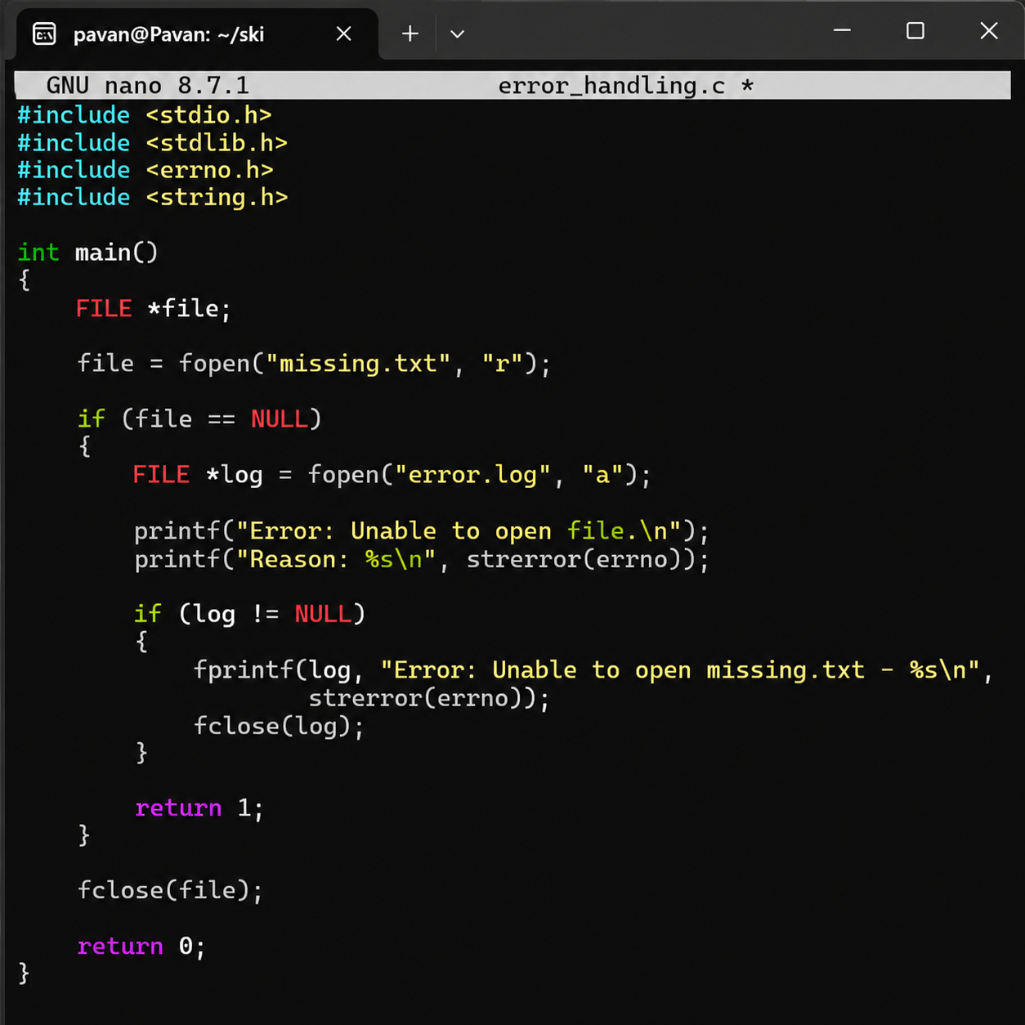
Output:
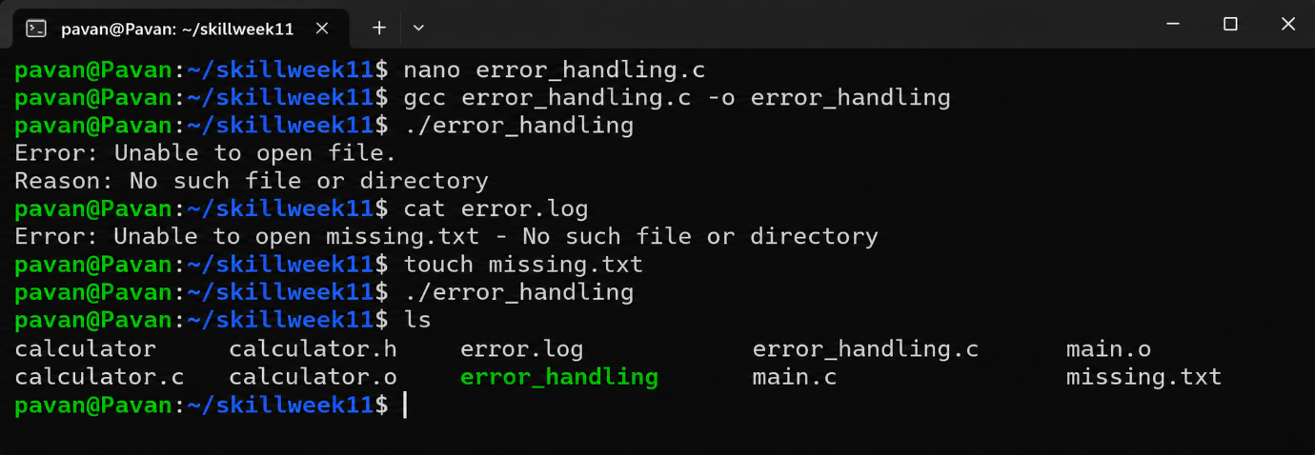
Observation
When missing.txt did not exist, the program detected the file-opening failure using fopen() and generated an error message using strerror(errno). The failure was also recorded in error.log. After creating the file, the error condition was removed.
Result
Runtime error detection, error-message generation, failure logging, and basic error recovery were successfully implemented and tested.
Aim
To use Valgrind to detect memory leaks and memory-related errors in a C program, properly release dynamically allocated memory, and verify that the program has no memory leaks.
Program:
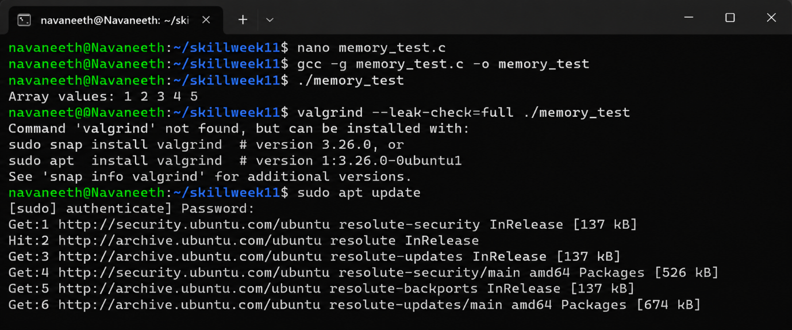
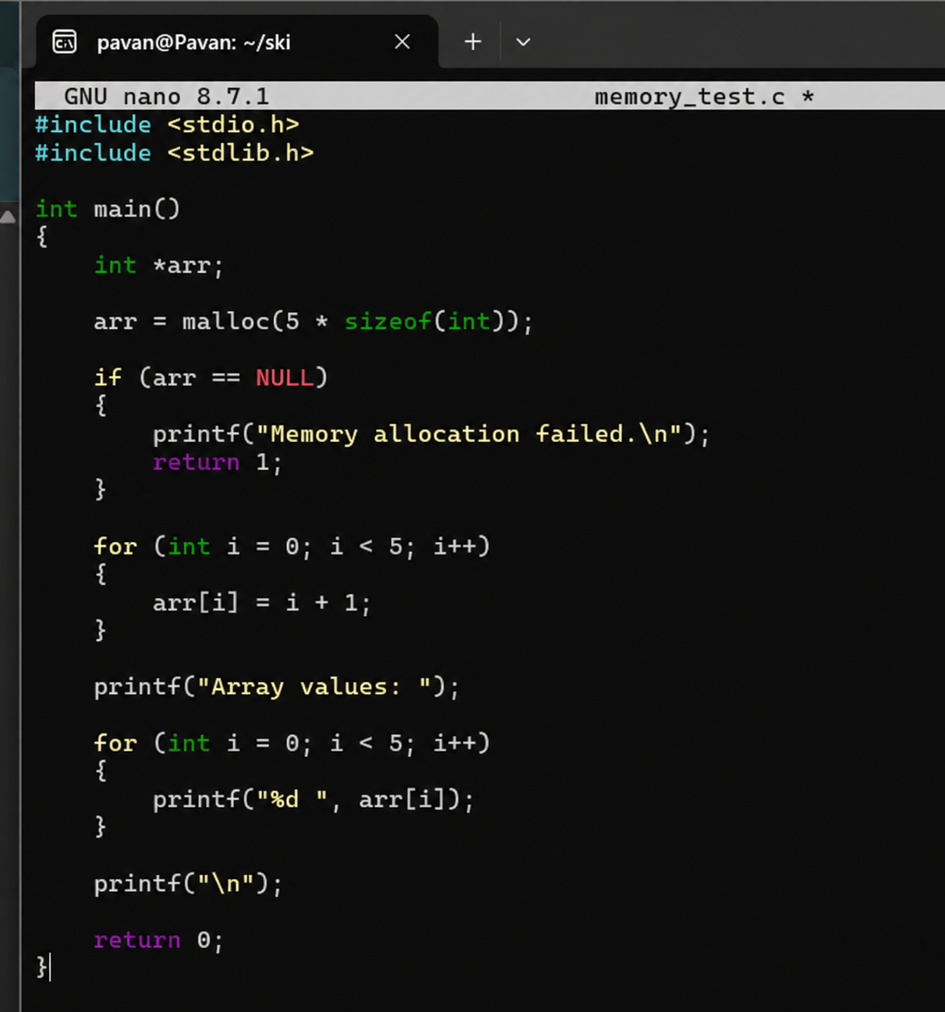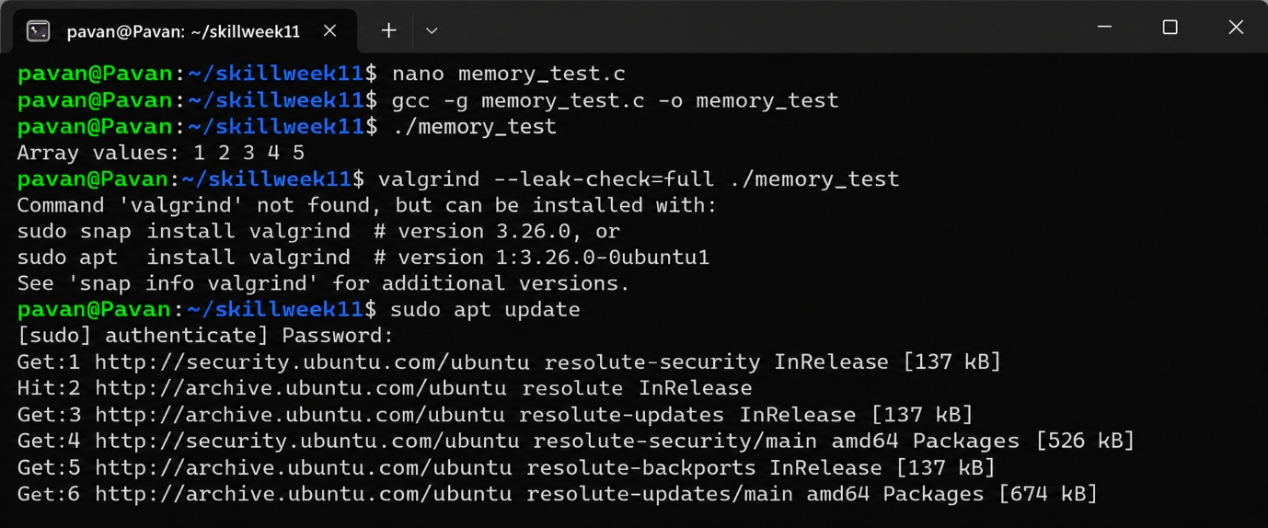
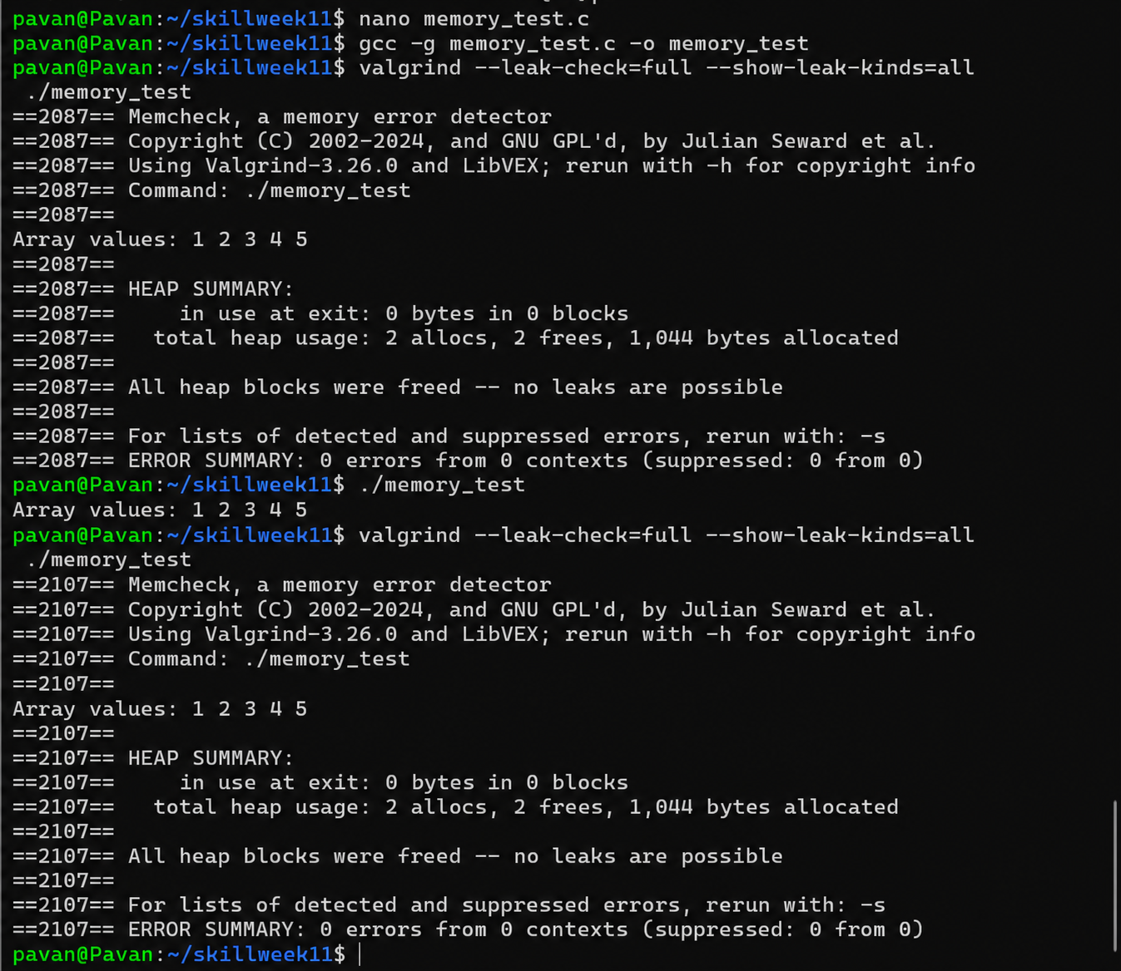

Observation
The memory allocated using malloc() was successfully released using free(). Valgrind reports no memory leaks.
Result
Memory allocation and cleanup were verified successfully using Valgrind

Aim
To design test cases, create a test script, automate program execution, verify outputs, compare results, and generate a test report.
Program:
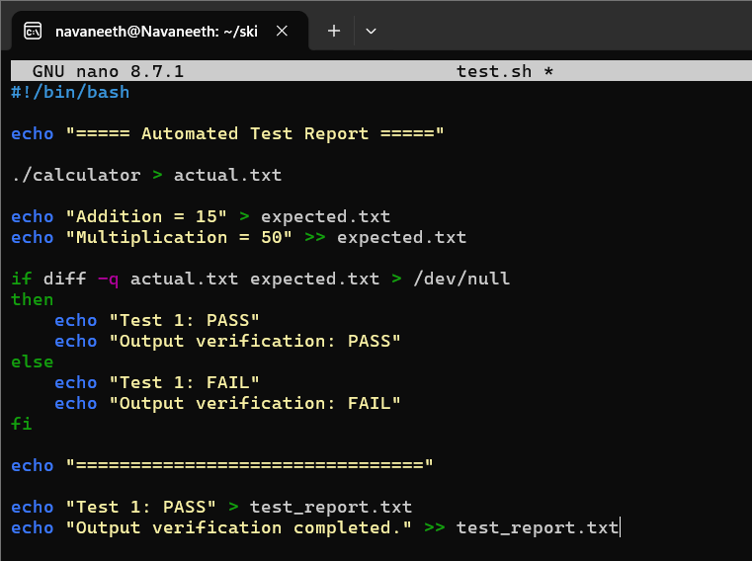
Output:
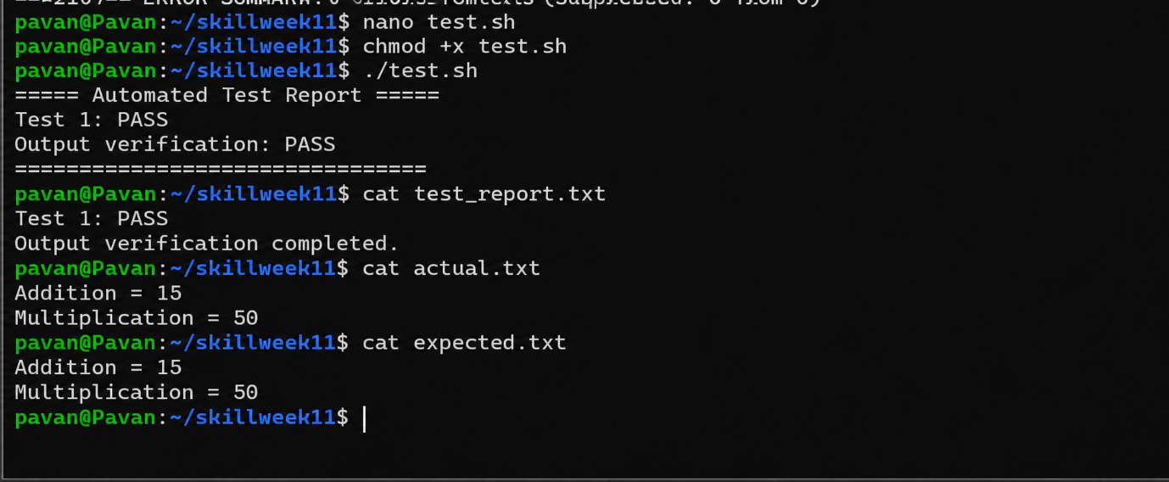

Observation
The test script automatically executed the program, compared the actual output with the expected output, and generated a test report.
Result
Automated testing, output comparison, and report generation were completed successfully.

